JUnit5 and Mockito4
JUnit
JUnit is a popular unit-testing framework in the Java ecosystem. JUnit 5 added many new features based on the Java 8 version of the language.
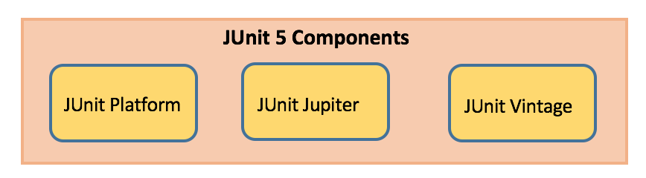
JUnit Platform
- Launches testing frameworks on the JVM
- Has TestEngine API used to build a testing framework that runs on the JUnit platform
JUnit Jupiter
- Blend of new programming model for writing tests and extension model for extensions
- Addition of new annotations like @BeforeEach, @AfterEach, @AfterAll, @BeforeAll etc.
JUnit Vintage
- Provides support to execute previous JUnit version 3 and 4 tests on this new platform
JUnit Maven Dependencies
- To implement JUnit5 based test cases in a project, add the following dependency to the pom.xml file of the project:

JUnit 5 Library
<dependency>
<groupId>org.junit.jupiter</groupId>
<artifactId>junit-jupiter</artifactId>
<version>5.8.2</version>
</dependency>
<dependency>
<groupId>org.mockito</groupId>
<artifactId>mockito-core</artifactId>
<version>4.5.1</version>
</dependency>
<dependency>
<groupId>org.mockito</groupId>
<artifactId>mockito-junit-jupiter</artifactId>
<version>4.5.1</version>
</dependency>

JUnit Annotations
Listed below are some commonly used annotations provided in it:

Annotation Description .
@Test Denotes a test method
@DisplayName Declares a custom display name for the test class or test method
@BeforeEach Denotes that the annotated method should be executed before each test method
@AfterEach Denotes that the annotated method should be executed after each test method
@BeforeAll Denotes that the annotated method should be executed before all test methods
@AfterAll Denotes that the annotated method should be executed after all test methods
@Disable Used to disable a test class or test method
@Tag Declare tags for filtering tests
@ExtendWith Register custom extensions

JUnit Assertions
Every test method must be evaluated against condition to true using assertions so that the test can continue to execute. JUnit Jupiter assertions are kept in the org.junit.jupiter.api.Assertions class. All of the methods are static.

Assertion Description .
assertEquals(expected, actual) Fails when expected does not equal actual
assertFalse(expression) Fails when expression is not false
assertNull(actual) Fails when actual is not null
assertNotNull(actual) Fails when actual is null
assertAll() Group many assertions and every assertion is executed even if one or more of them fails
assertTrue(expression) Fails if expression is not true
assertThrows() Class to be tested is expected to throw an exception

@Test
void testAssertEqual() {
assertEquals("ABC", "ABC");
assertEquals(20, 20, "optional assertion message");
assertEquals(2 + 2, 4);
}

@Test
void testAssertFalse() {
assertFalse("FirstName".length() == 10);
assertFalse(10 > 20, "assertion message");
}

@Test
void testAssertNull() {
String str1 = null;
String str2 = "abc";
assertNull(str1);
assertNotNull(str2);
}

@Test
void testAssertAll() {
String str1 = "abc";
String str2 = "pqr";
String str3 = "xyz";
assertAll("strings",
() -> assertEquals(str1,"abc"),
() -> assertEquals(str2,"pqr"),
() -> assertEquals(str3,"xyz")
);

}

@Test
void testAssertTrue() {
assertTrue("FirstName".startsWith("F"));
assertEquals("Illegal Argument Exception occured", exception.getMessage());
}

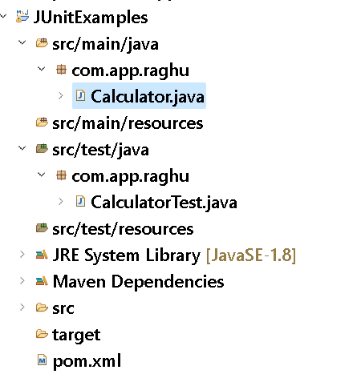

pom.xml:-
<properties>
<maven.compiler.source>1.8</maven.compiler.source>
<maven.compiler.target>1.8</maven.compiler.target>
</properties>
<dependencies>
<dependency>
<groupId>org.junit.jupiter</groupId>
<artifactId>junit-jupiter</artifactId>
<version>5.8.2</version>
</dependency>
<dependency>
<groupId>org.mockito</groupId>
<artifactId>mockito-core</artifactId>
<version>4.5.1</version>
</dependency>
<dependency>
<groupId>org.mockito</groupId>
<artifactId>mockito-junit-jupiter</artifactId>
<version>4.5.1</version>
</dependency>

</dependencies>

SERVICE CLASS: -
package com.app.raghu;

public class Calculator {

public int multiply(int a, int b) {
return a * b;
}
}

TEST CLASS: -
package com.app.raghu;

import static org.junit.jupiter.api.Assertions.assertEquals;
import static org.junit.jupiter.api.Assertions.assertNotEquals;

import org.junit.jupiter.api.AfterEach;
import org.junit.jupiter.api.BeforeEach;
import org.junit.jupiter.api.DisplayName;
import org.junit.jupiter.api.MethodOrderer;
import org.junit.jupiter.api.Order;
import org.junit.jupiter.api.Test;
import org.junit.jupiter.api.TestMethodOrder;

@TestMethodOrder(value = MethodOrderer.OrderAnnotation.class)
public class CalculatorTest {

Calculator calculator;

@BeforeEach
void setUp() {
calculator = new Calculator();
}

@Test
@DisplayName("Test Multiplication ")
@Order(20)
void testMultiply() {
assertEquals(20, calculator.multiply(4, 5),
"Regular multiplication should work");
}

@Test
@Order(10)
//@Disabled
void testZero() {
assertNotEquals(100, calculator.multiply(4, 0),
"Regular multiplication should work");
}

@AfterEach
void clean() {
calculator = null;
}
}

JUNIT TEST FOR DATABASE CONNECTION SINGLETON TESTING
pom.xml
<dependency>
<groupId>com.mysql</groupId>
<artifactId>mysql-connector-j</artifactId>
<version>8.0.32</version>
</dependency>

SERVICE CLASS: -
package com.app.raghu;

import java.sql.Connection;
import java.sql.DriverManager;
import java.sql.SQLException;

public class ConnectionUtil {

private static Connection con = null;

static {
try {
con = DriverManager.getConnection("jdbc:mysql://localhost:3306/bootdb", "root", "root");
} catch (SQLException e) {
e.printStackTrace();
}
}

public static Connection getConnection() {
return con;
}
}

TEST CLASS: -
package com.app.raghu;

import static org.junit.jupiter.api.Assertions.assertAll;
import static org.junit.jupiter.api.Assertions.assertNotNull;
import static org.junit.jupiter.api.Assertions.assertSame;

import java.sql.Connection;

import org.junit.jupiter.api.AfterEach;
import org.junit.jupiter.api.BeforeEach;
import org.junit.jupiter.api.Test;

public class ConnectionUtilTest {

Connection con1, con2;

@BeforeEach
public void setup() {
con1 = ConnectionUtil.getConnection();
con2 = ConnectionUtil.getConnection();
}

@Test
public void testNotNull() {
assertAll("Connections",
()->assertNotNull(con1),
()->assertNotNull(con2)
);
}

@Test
public void testSameRef() {
assertSame(con2, con1);
}

@AfterEach
public void clean() {
con1 = con2 = null;
}
}

MOCKITO

Mockito is a java based mocking framework, used in conjunction with other testing frameworks such as JUnit. It internally uses Java Reflection API and allows to create objects of a service. A mock object returns a dummy data and avoids external dependencies.

SERVICE CODE: -

package com.app.raghu;

import java.sql.SQLException;
import java.util.List;

public class Repository {
public List<String> getData() throws SQLException {
return null;
}
}
-------------------------------------------------------------------
package com.app.raghu;

import java.sql.SQLException;
import java.util.Arrays;
import java.util.List;
import java.util.stream.Collectors;

public class Service {
private Repository repository;

public Service(Repository repository) {
this.repository = repository;
}

public List<String> getDataLen() {
try {
return repository.getData().stream()
.filter(data -> data.length() < 5)
.collect(Collectors.toList());
} catch (SQLException e) {
return Arrays.asList();
}
}
}

TEST CLASS: -

package com.app.raghu;

import java.sql.SQLException;
import java.util.Arrays;
import java.util.List;

import org.junit.jupiter.api.Assertions;
import org.junit.jupiter.api.Test;
import org.junit.jupiter.api.extension.ExtendWith;
import org.mockito.InjectMocks;
import org.mockito.Mock;
import org.mockito.Mockito;
import org.mockito.junit.jupiter.MockitoExtension;

@ExtendWith(MockitoExtension.class)
class ServiceTest {

@Mock
Repository repository;

@InjectMocks
Service service;

@Test
void testSuccess() {
// Setup mock scenario
try {
Mockito.when(repository.getData()).thenReturn(
Arrays.asList("A", "B", "CDEFGHIJK", "12345", "1234"));
} catch (SQLException e) {
e.printStackTrace();
}

// Execute the service that uses the mocked repository
List<String> data = service.getDataLen();

// Validate the response
Assertions.assertNotNull(data);
Assertions.assertEquals(3, data.size());
}

@Test
void testException() {
// Setup mock scenario
try {
Mockito.when(repository.getData()).thenThrow(
new SQLException("Connection Exception"));
} catch (SQLException e) {
e.printStackTrace();
}

// Execute the service that uses the mocked repository
List<String> data = service.getDataLen();

// Validate the response
Assertions.assertNotNull(data);
Assertions.assertEquals(0, data.size());
}
}

FB: http://facebook.com/groups/thejavatemple

